# SRTING HANDLING FUNCTIONS

1. **strcat()**

It is used to concatenate two string

#include <stdio.h>

#include<string.h>

int main()

{

char str1[]="Good";

char str2[]="Moring";

printf("%s",strcat(str1,str2));

return 0;

}

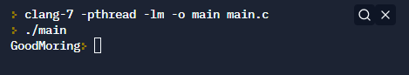

1. **strlen()**

It is used to show the length of a string

#include <stdio.h>

#include<string.h>

int main()

{

char str1[]="Good Morning";

int length=strlen(str1);

printf("length of the string =%d",length);

return 0;

}

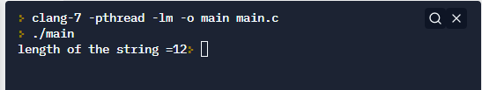

**3) strrey()**

Use to store reverse of a string

#include<stdio.h>

#include<conio.h>

#include<string.h>

void main()

{

char str1[]="Good morning";

clrscr();

printf("%s",strrev(str1));

getch();

}

**4) strcpy()**

is It used to copies one string to another

#include <stdio.h>

#include<string.h>

int main()

{

char str1[100],str2[100];

printf("Enter the string");

gets(str1);

strcpy(str2,str1);

printf("after copying,string2 is %s",str2);

return 0;

}

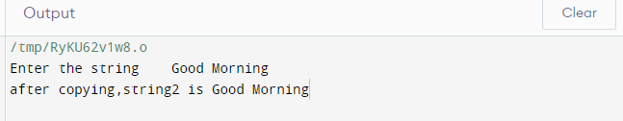

**5) strcmp()**

It is used to compare two strings

#include <stdio.h>

#include<string.h>

int main()

{

char str1[]="Good Morning";

char str2[]="Good Night";

int comp=strcmp(str1,str2);

printf("after comparing the strings,differece is %d",comp);

return 0;

}

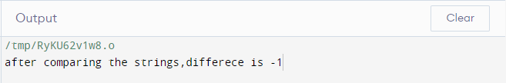

**6) strlwr()**

It is used to convert the input into lower case .

#include<stdio.h>

#include<conio.h>

#include<string.h>

void main()

{

char str1[]="GOOD MORNING";

clrscr();

printf("%s",strlwr(str1));

getch();

}

**7) strupr**

It is used to convert the input into upper case letter.

#include<stdio.h>

#include<conio.h>

#include<string.h>

void main()

{

char str1[]="GOOD MORNING";

clrscr();

("%s",strupr(str1));

getch();

}

**8) strcmpi()**

It is same as Strcmp function.But this function negotiate case A and a are treated as same

#include <stdio.h>

#include<string.h>

int main()

{

char str1[]="Good Morning";

char str2[]="Good Night";

int comp=strcmpi(str1,str2);

printf("after comparing the strings,differece is %d",comp);

return 0;

}

**9) strncat()**

It is used to concatenate n characters of second string to first string

#include <stdio.h>

#include <string.h>

int main()

{

char str1[] = "Welcome to ooty\t";

char str2[] = "Nice to meent you all";

strncat(str1,str2, 17);

printf("After combining string; %s", str1);

return 0;

}

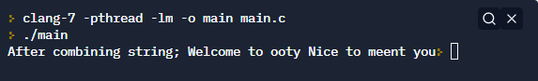

**10) strncmp()**

It is used to compare n characters of second string to first string.

#include <stdio.h>

#include <string.h>

int main()

{

char str1[20] = "Good Morning";

char str2[20] = "Good Night";

int comp=strncmp(str1,str2, 7);

printf("After comparing,difference is %d",comp);

return 0;

}

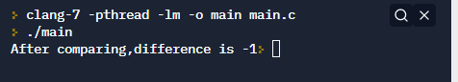

**11) strncpy()**

It is used to copy given no:of characters of first string to second string.

#include <stdio.h>

#include<string.h>

int main()

{

char str1[]="Good Morning";

char str2[100];

strncpy(str2,str1, 6);

printf("after copying,string2 is: %s",str2);

return 0;

}

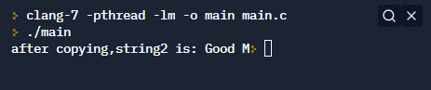

**12) strstr()**

It returns pointer to first occurrence of string 2 in string 1.